Season For Peace and Nonviolence 2020
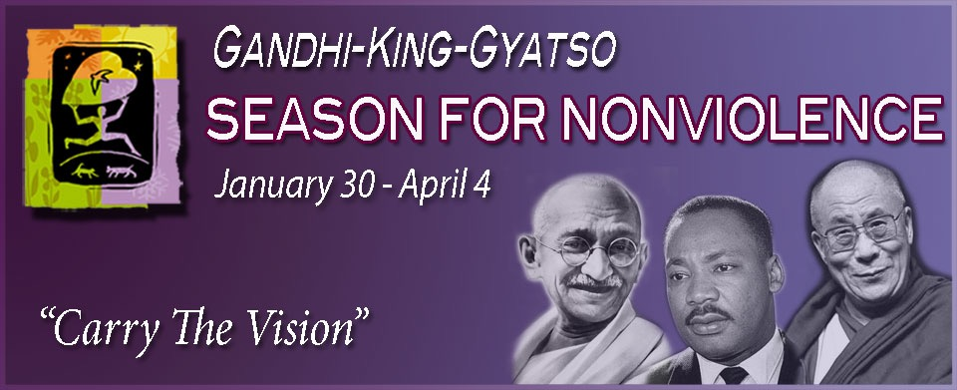
“Carry the Vision”
This year marks more than two decades for the grassroots movement The Season for Nonviolence commemorating the memorial dates of Mahatma Ghandi and Rev. Martin Luther King, Jr., which span the 64 days between Gandhi’s assassination on January 30th and King’s on April 4th. During this time, our spiritual community is invited to join others in focusing on attaining peace utilizing the principles of nonviolence that these two great men exemplified. The youth of this community ask you to join with them to practice these daily principles as we continue to use Perfect Vision in 2020 to Carry the Vision of peace. Communities from all over the world use this special time to heighten the awareness of love, compassion, cooperation, acceptance and diversity.
Look for more information to come & visit The Association for Global New Thought at www.agnt.org

PS
***Looks like we aren't the only ones who like passports
http://www.agnt.org/order-peaceport

